**Sri Lanka Institute of Information Technology**



**Assignment**

**MLB_PG.11.01_10**

**Resource booking System**

Information System and Data Modeling (ISDM) - IT1090

B.Sc. (Hons) in Information Technology

Assignment Cover Sheet

|  |  |
| --- | --- |
| **PROJECT ID** | **MLB_PG.11.01_10** |
| **CASE STUDY NAME** | **Resource booking System** |

**Group Details:**

|  |  |  |
| --- | --- | --- |
|  | **Student Registration Number** | **Student Name** |
| **1** | IT20014186 | K.K.D.P.Kannangara |
| **2** | IT20022624 | N.V.C.Pinto |
| **3** | IT20237486 | H.M.Y.B.Gunarathne |
| **4** | IT20259884 | W.N.D.Wijerathne |
| **5** | IT20114244 | S.L.V.Wijerathne |

**CONTENT**

1. Hypothetical Scenario……………………………………………..

2. Requirements Analysis……………………………………………

3. Entity Relationship Diagram………………………………………

4. Relational Model…………………………………………………...

5. Physical Database Design……………………………………….....

6. Data stored in Database………………………………………….....

7. Performance Requirements………………………………………...

8. Security Requirements……………………………………………..

9. Sample SQL results………………………………………………..

10. Comments

11. References

* **HYPOTHETICAL SCENARIO**

Our case study is a **Resource booking system** which called LILLI club, anyone can access or register on our website. You can book our resources through our website or by visiting the club.

That club services are,

* + Outdoor auditorium
  + Indoor auditorium
  + Ground
  + Conference room
  + Computer lab

There are 12 web pages in our system. They are,

* Login page
* Registration page
* Home page
* Add booking page
* News page
* History page
* Our community

The User can go through these web pages in our system and fulfill their needs from our system well and the user can go through these web pages in our system and meet their needs well in our system. Alternatively you can come to the club and meet your needs through the receptionist.

The Lilli_Club_DB database that we created for our resource booking system provides information about every occasions of our system.

They are,

* 1. • Information about Resource
  2. • Information about payment methods
  3. • Information about our facilities
  4. • Information about social media connectivity
  5. • Information about contact details
  6. • Information about news details
  7. • Information about registration details
  8. • Information about locations
  9. • Information about our service
  10. • Information about customer details
* **Requirement Analysis**
* **User registration and logging**

All users who wish to use the **Lilli Club.com** website must first register. Gets some personal data. After registration, they can access the website by entering their username and password. You can also register by coming to the club. Resources can be reserved for anyone who registers.

* **Services**

Lily Club's registered customers have a number of privileges

These resources are categorized. Information on prices and resources is available on our website or through the receptionist.

We have an efficient staff under the Resource Manager of our organization.

* **Payment**

There are several ways to pay for Lilli club resources. Payment can be made by payment card or at the club or at any bank across the country. Receipt will be issued for all reservations.

* **Special features**

Customers can locate the club via Google Maps. There is a specially equipped auditorium area for the dignitaries of our auditorium. We have a special computer unit in our computer lab. The conference room is equipped with state-of-the-art equipment and the room is luxuriously arranged.

* **Administration**

Our website is run by a very experienced and experienced board of directors. They have an IT degree and they are constantly updating the website. In dealing with them, our staff is committed to resolving any issues that may arise according to the needs of the users.

* **Contact**

For information on our club, the customer can contact us via social media such as Facebook, Instagram and Twitter. You can also contact us by phone number and email.

* **Security procedures**

Halo.com accepts responsibility for electronic cards, payments and orders. No virus can be socialized through the web. Also, all users’ data is securely stored in a Microsoft SQL database called Lilli_Club_DB

* **Entity Relationship Diagram**

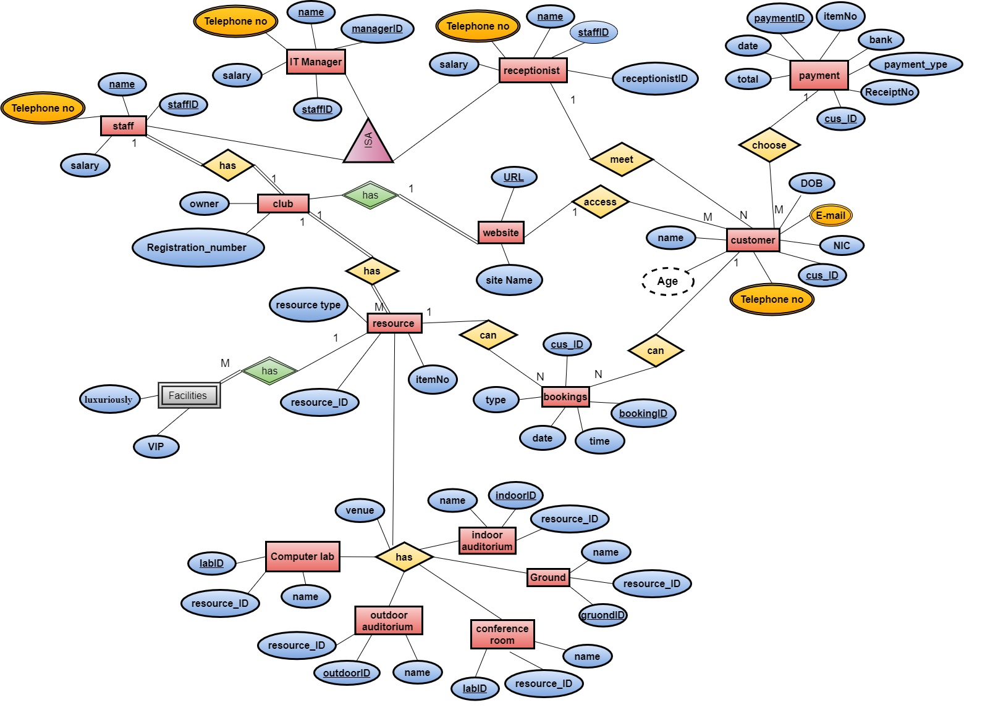

* **Relational Model**

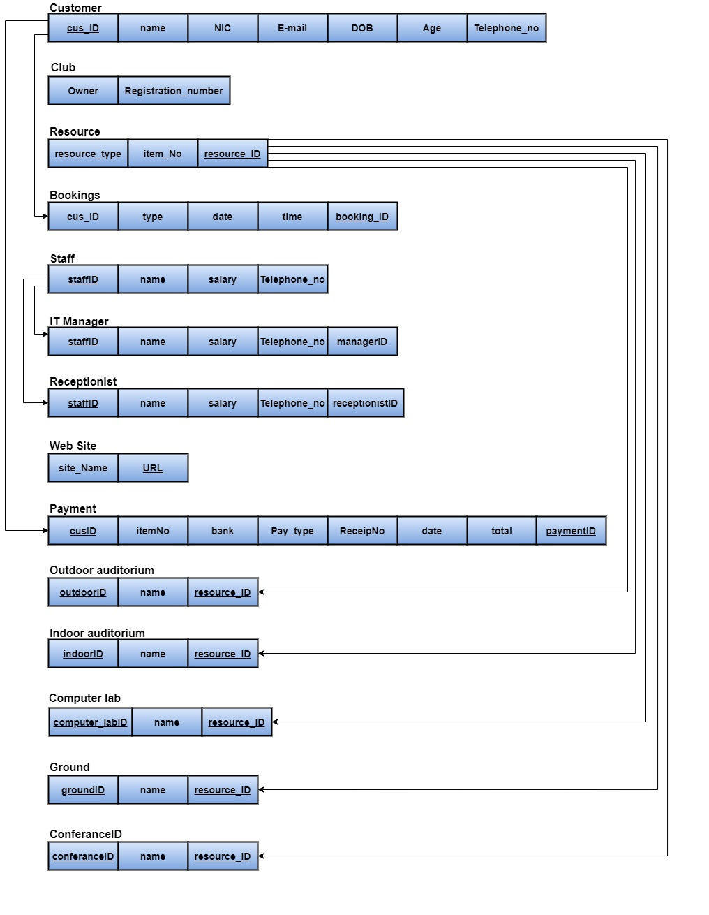

* **Physical Database Design**

CREATE TABLE Customer1(

cus_ID varchar(15),

name varchar(20),

NIC varchar(10),

email varchar(30),

DOB date,

age int,

Telephone_no varchar(15),

constraint Customer1_pk PRIMARY KEY(cus_ID)

);

CREATE TABLE payment2(

payment2ID varchar(15),

cus_ID varchar(15),

itemNo int,

total float,

bank varchar(20),

date date ,

pay_Type varchar(20),

receipNo int,

constraint payment2_pk PRIMARY KEY(payment2ID),

constraint Customer1_fk FOREIGN KEY(cus_ID) REFERENCES Customer1(cus_ID)

);

CREATE TABLE staff(

staffID varchar(15),

Telephone_no varchar(15),

name varchar(15),

salary float,

constraint staff_pk PRIMARY KEY(staffID)

);

CREATE TABLE receptionist(

receptionistID varchar(15),

Telephone_no varchar(15),

name varchar(15),

salary float,

staffID varchar(15),

constraint receptionist_pk PRIMARY KEY(receptionistID),

constraint staff_fk FOREIGN KEY(staffID) REFERENCES staff(staffID)

);

CREATE TABLE IT_Manager(

managerID varchar(15),

Telephone_no varchar(15),

name varchar(15),

salary float,

staffID varchar(15),

constraint IT_Manager_pk PRIMARY KEY(managerID),

constraint staff_fk FOREIGN KEY(staffID) REFERENCES staff(staffID)

);

CREATE TABLE website(

URL varchar(15),

site_name varchar(15),

constraint website_pk PRIMARY KEY(URL)

);

CREATE TABLE club(

registation_number varchar(20),

owner varchar(20)

);

CREATE TABLE resources(

resourcesID varchar(15),

item_no int,

resource_type varchar(15),

constraint resources_pk PRIMARY KEY(resourcesID)

);

CREATE TABLE booking(

bookingID varchar(15),

cus_ID varchar(15),

type varchar(15),

date date,

time time,

constraint booking_pk PRIMARY KEY(bookingID),

constraint Customer1_fk FOREIGN KEY(cus_ID) REFERENCES Customer1(cus_ID)

);

CREATE TABLE indoor_auditorium(

name varchar(25),

indoorID varchar(15),

resourcesID varchar(15),

constraint indoor_auditorium_pk PRIMARY KEY(indoorID),

constraint resources_fk FOREIGN KEY(resourcesID) REFERENCES resources(resourcesID)

);

CREATE TABLE outdoor_auditorium(

name varchar(25),

outdoorID varchar(15),

resourcesID varchar(15),

constraint outdoor_auditorium_pk PRIMARY KEY(outdoorID),

constraint resources_fk FOREIGN KEY(resourcesID) REFERENCES resources(resourcesID)

);

CREATE TABLE Ground(

name varchar(25),

groundID varchar(15),

resourcesID varchar(15),

constraint Ground_pk PRIMARY KEY(groundID),

constraint resources_fk FOREIGN KEY(resourcesID) REFERENCES resources(resourcesID)

);

CREATE TABLE conference_room(

conferenceID varchar(10),

name varchar(25),

resourcesID varchar(15),

constraint confrence_room_pk PRIMARY KEY(conferenceID),

constraint resources_fk FOREIGN KEY(resourcesID) REFERENCES resources(resourcesID)

);

CREATE TABLE computer_lab(

computer_labID varchar(15),

name varchar(25),

resourcesID varchar(15),

constraint computer_lab_pk PRIMARY KEY(computer_labID),

constraint resources_fk FOREIGN KEY(resourcesID) REFERENCES resources(resourcesID)

);

* **Data stored in Database**

INSERT INTO payment2

VALUES

(60500,'IT20234',675,15000.00,'Bank of Ceylon','15-12-2017','visa',36436),

(12367,'IT20165',987,1000.00,'Commercial bank','22-01-1999','master',34235),

(24589,'IT24434',362,3400.00,'Peoples bank','02-10-2018','american',343214),

(61782 ,'IT22694',451,50000.00,'Pan asia bank','16-04-2020','visa',1412),

(79001, 'IT28925',653,2000.00,'Bank of Ceylon','10-11-2019','master',4687)

INSERT INTO Customer1

VALUES

('IT20234','Yehan','991245689V','yehangunarathne@gmail.com','10-09-1999',21,0701474424),

('IT20165','Nuwan','997454646V','nuwandilsara@gmail.com','20-07-1999',21,0771896541),

('IT24434','Dulan','991729898V','dulankannangara@gmail.com','30-02-1999',21,0714571236),

('IT22694','Vimukthi','993565245V','vimukthipinto@gmail.com','17-06-1999',21,0761474563),

('IT28925','Lahiru','997856321V','lahiruwijerathne@gmail.com','13-09-1999',21,0781554489)

INSERT INTO receptionist

VALUES

('W753159',0771478632,'Thadiya',65000.00,'10-12-1979','F1456'),

('W569812',0778499426,'Dilmi',54000.00,'15-04-1985','F7896'),

('W258963',0714589636,'Kaveesha',85000.00,'14-11-1976','F2569'),

('W125698',0725482362,'Maleesha',78000.00,'20-08-1988','F8523'),

('W114598',0789631453,'Dilu',94000.00,'29-09-1981','F1594')

INSERT INTO IT_Manager

VALUES

('M423651',0789631478,'Kusal',102000.00,'S258749','B1456'),

('M951357',0789631478,'Supun',116000.00,'S892162','B4505'),

('M882146',0789631478,'Nikila',131000.00,'S559656','B4453'),

('M963125',0789631478,'Kalum',165000.00,'S445625','B8612'),

('M215687',0789631478,'Chathura',92000.00,'S155622','B8931')

INSERT INTO staff

VALUES

('F1456',0751596324,'Jeny',82000.00),

('F7896',0782952535,'Thimira',78000.00),

('F2569',0714526859,'Chamara',157000.00),

('F8523',0772561552,'Dilsara',90000.00),

('F1594',0721518551,'Sadeesha',99000.00)

INSERT INTO website

VALUES

('https://lilliclub.com/','www.lilliclub.com'),

('https://lilliclub.net/','www.lilliclub.net'),

('https://lilliclub.lk/','www.lilliclub.lk'),

('https://lilliclub.uk/','www.lilliclub.uk'),

('https://lilliclub.us/','www.lilliclub.us')

INSERT INTO club

VALUES

('RG145236','Saman'),

('RG234653','Kapila'),

('RG756563','Nimal'),

('RG389962','Sunil'),

('RG569965','Gagani')

INSERT INTO resources

VALUES

('RE01','NO5466','Ground'),

('RE02','NO6165','Indoor auditorium'),

('RE03','NO5956','Ourdoor auditorium'),

('RE04','NO7782','Computer lab'),

('RE05','NO3299','Conference room')

INSERT INTO booking

VALUES

('BK14253','IT20234','Ground','05-05-2020','14:45 PM'),

('BK54963','IT20165','Indoor auditorium','06-05-2020','15:05 PM'),

('BK19662','IT24434','Ourdoor auditorium','07-05-2020','12:55 PM'),

('BK79522','IT22694','Computer lab','08-05-2020','16:45 PM'),

('BK29528','IT28925','Conference room','09-05-2020','10:45 PM')

INSERT INTO indoor_auditorium

VALUES

('nelum auditorium','IN001','RE01'),

('manel auditorium','IN002','RE02'),

('pichcha auditorium','IN003','RE03'),

('kusum auditorium','IN004','RE04'),

('lilly auditorium','IN005','RE05')

INSERT INTO outdoor_auditorium

VALUES

('meththa auditorium','Out001','RE01'),

('muditha auditorium','Out002','RE02'),

('karuna auditorium','Out003','RE03'),

('upekka auditorium','Out004','RE04'),

('shraddha auditorium','Out005','RE05')

INSERT INTO Ground

VALUES

('kandekale','GR001','RE01'),

('Ac','GR002','RE02'),

('nagenatharu','GR003','RE03'),

('sugathpala','GR004','RE04'),

('waterege','GR005','RE05')

INSERT INTO conference_room

VALUES

('A Conferance Room','CON001','RE01'),

('B Conferance Room','CON002','RE02'),

('C Conferance Room','CON003','RE03'),

('D Conferance Room','CON004','RE04'),

('E Conferance Room','CON005','RE05')

INSERT INTO Computer_lab

VALUES

('501 Computer Lab','COM001','RE01'),

('502 Computer Lab','COM002','RE02'),

('503 Computer Lab','COM003','RE03'),

('504 Computer Lab','COM004','RE04'),

('506 Computer Lab','COM005','RE05')

* **PERFORMANCE REQUIREMENTS**
* Unregistered Customers can register to the system and create a user account.
* Registered Customers can update their user account details.
* Receptionist and IT Managers can update and delete operations in the system.
* Both Registered Customers and Unregistered Customers can access the contact us and about us services
* Only Registered Customers can access the services in the system.
  + **SECURITY REQUIREMENTS**
* Unregistered Customers can’t access the entire system.
* After registration into the system, an email sent to verify the user account.
* Registered Customers should verify their user login credentials.
* Only Registered Customers have permission to retrieve all services in the system.
* Inform Customers to check all details again before submitting details for relevant services (send mails and bills) in the system.
* Confirm customer payment method whether credit card, debit card, PayPal or cash.
* Before making the payment inform the customer to check card details again.
* Verify customer card details.
* Send confirmation messages and e-bills to customers
* Protect user information and backup the customer details and all tractions details.

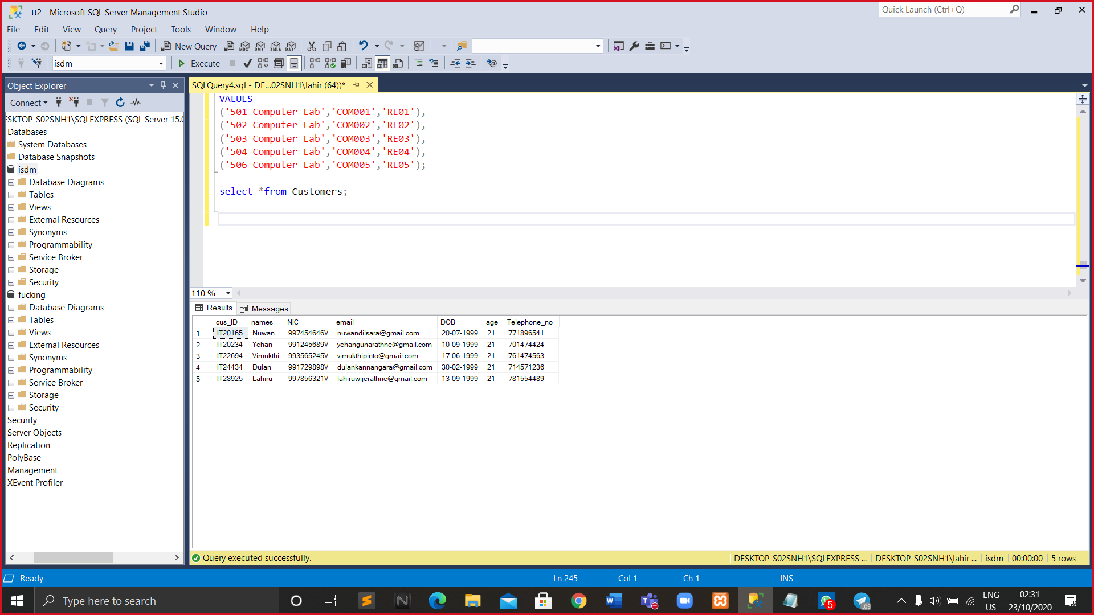**1.**

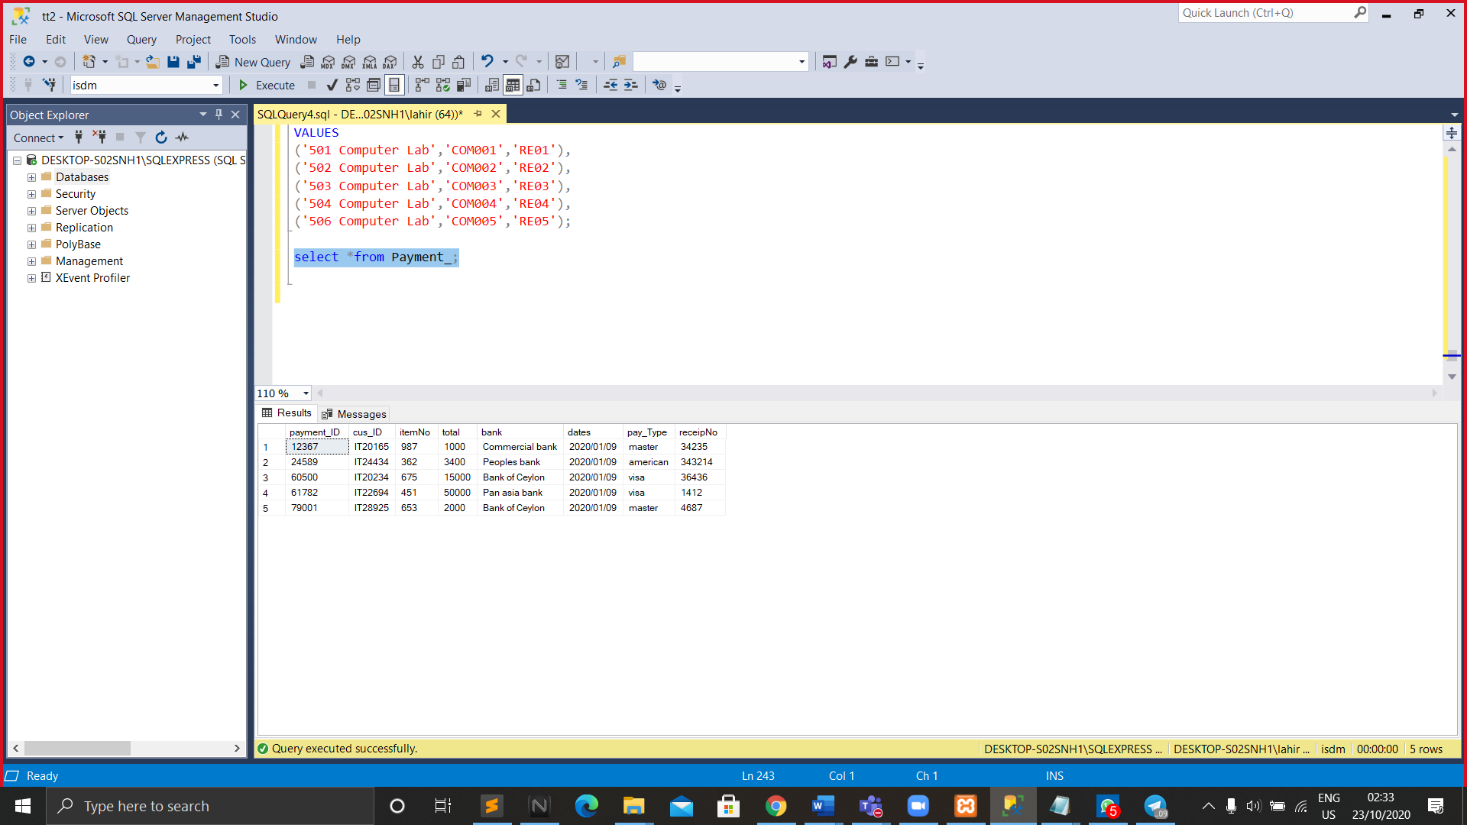**2.**

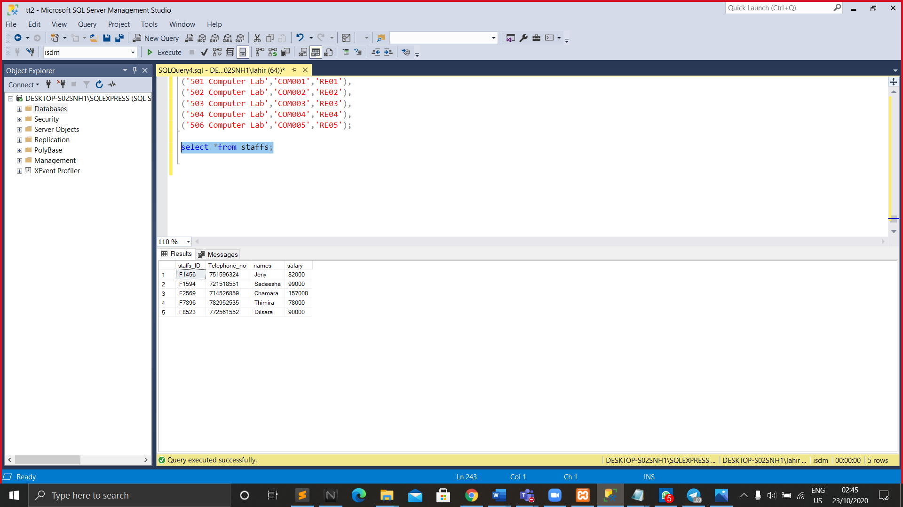**3.**

**4.** 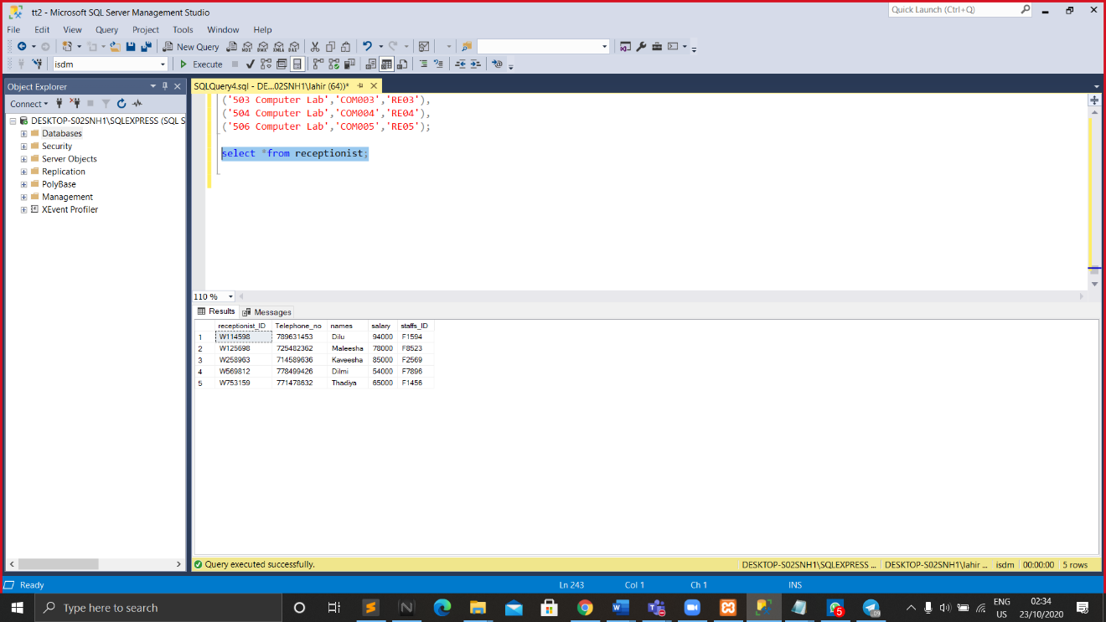

**5.**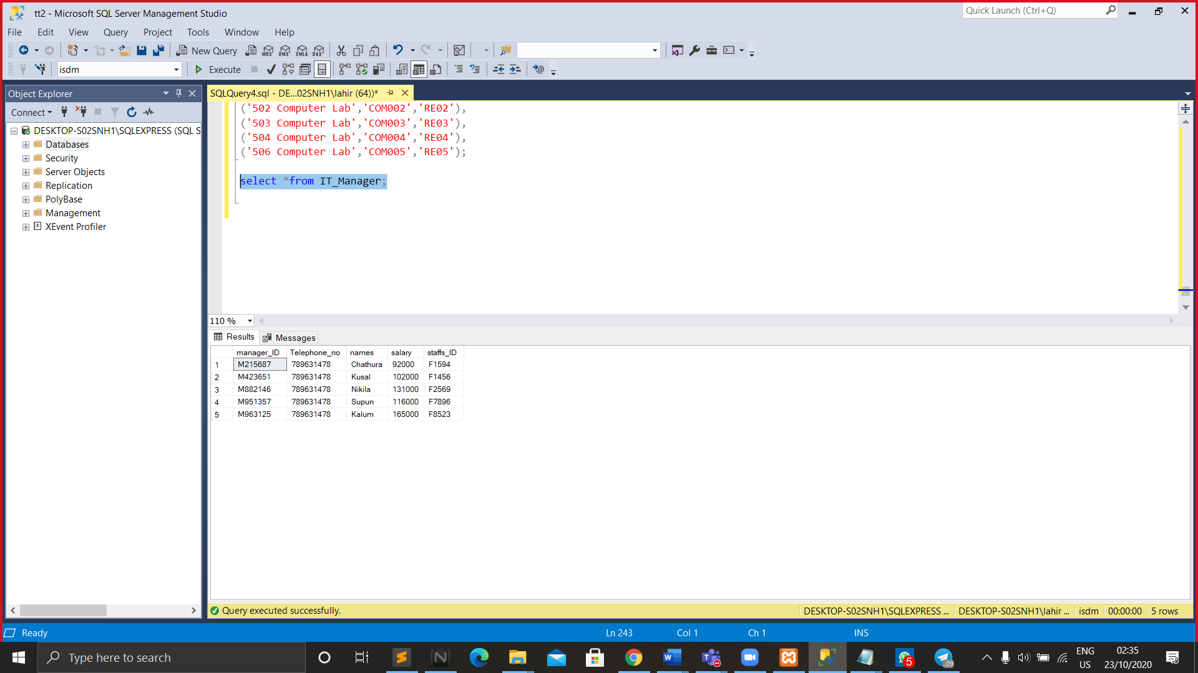

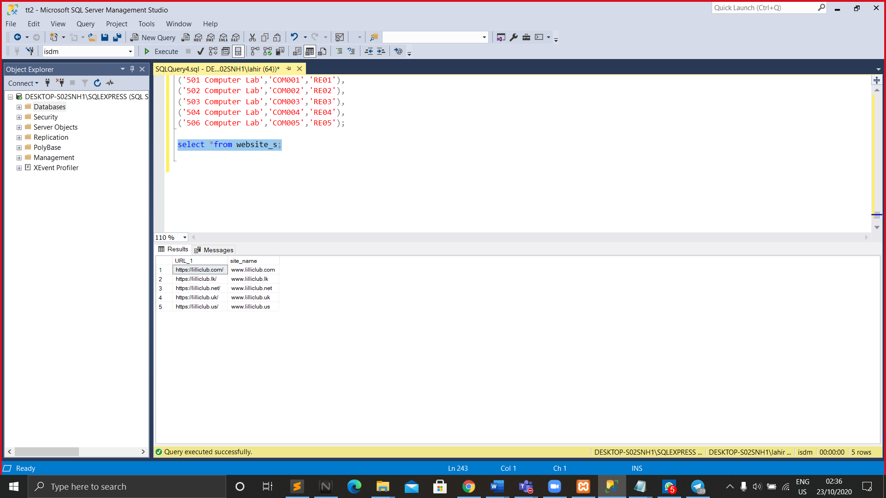**6.**

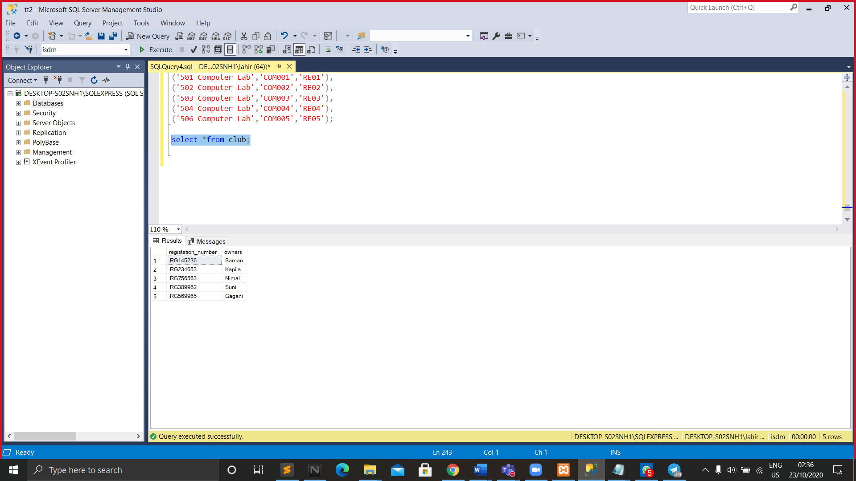**7.**

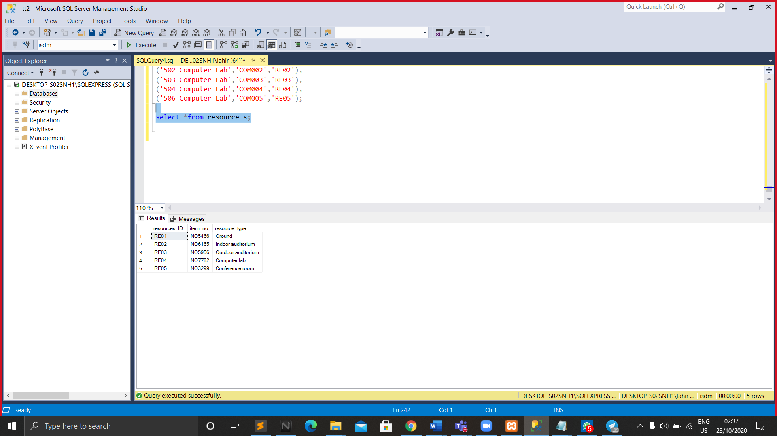**8.**

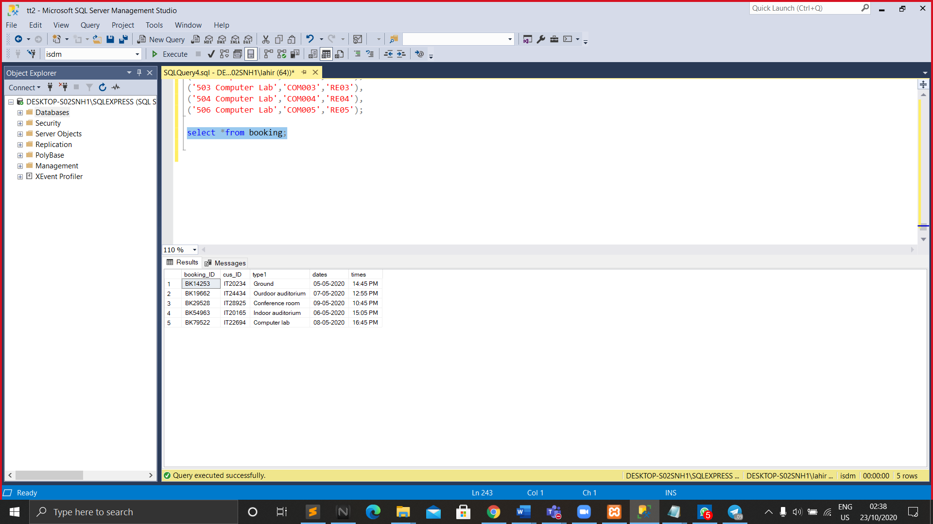**9.**

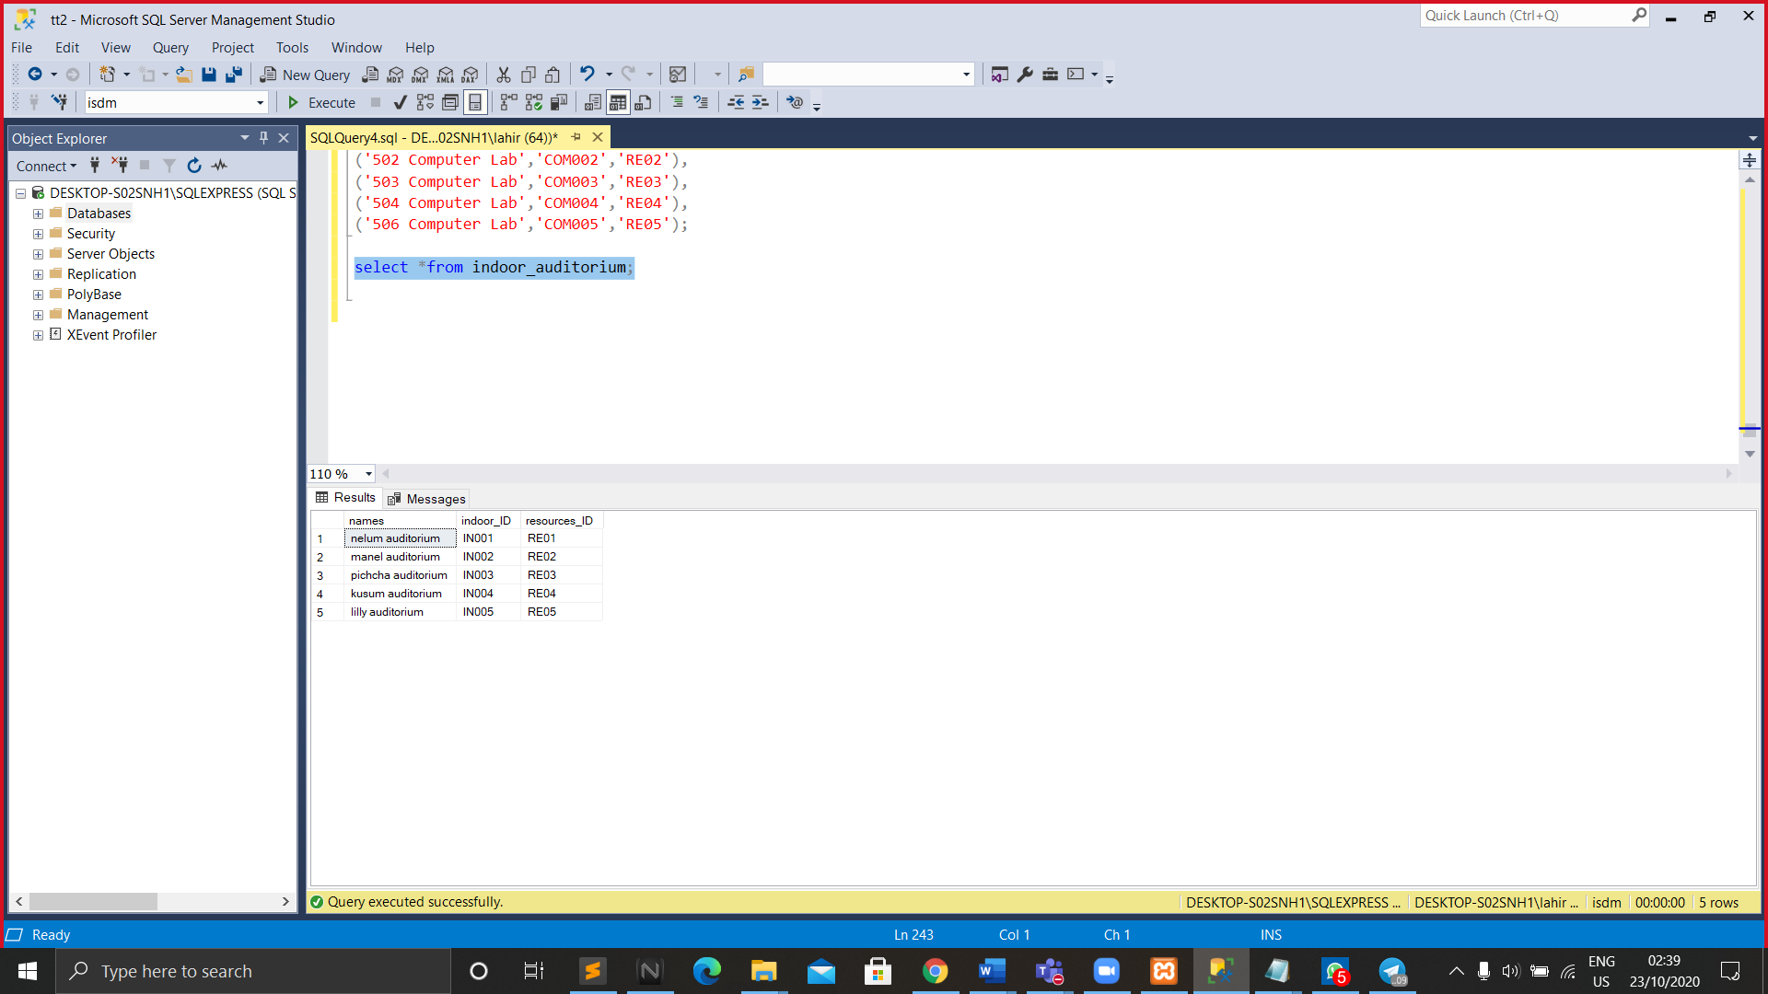10.

**11.**

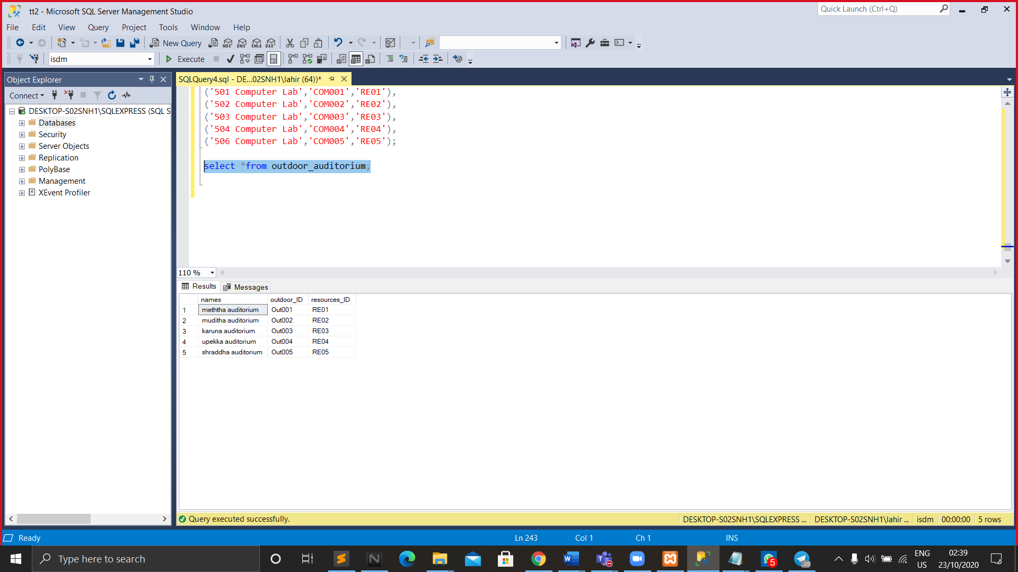

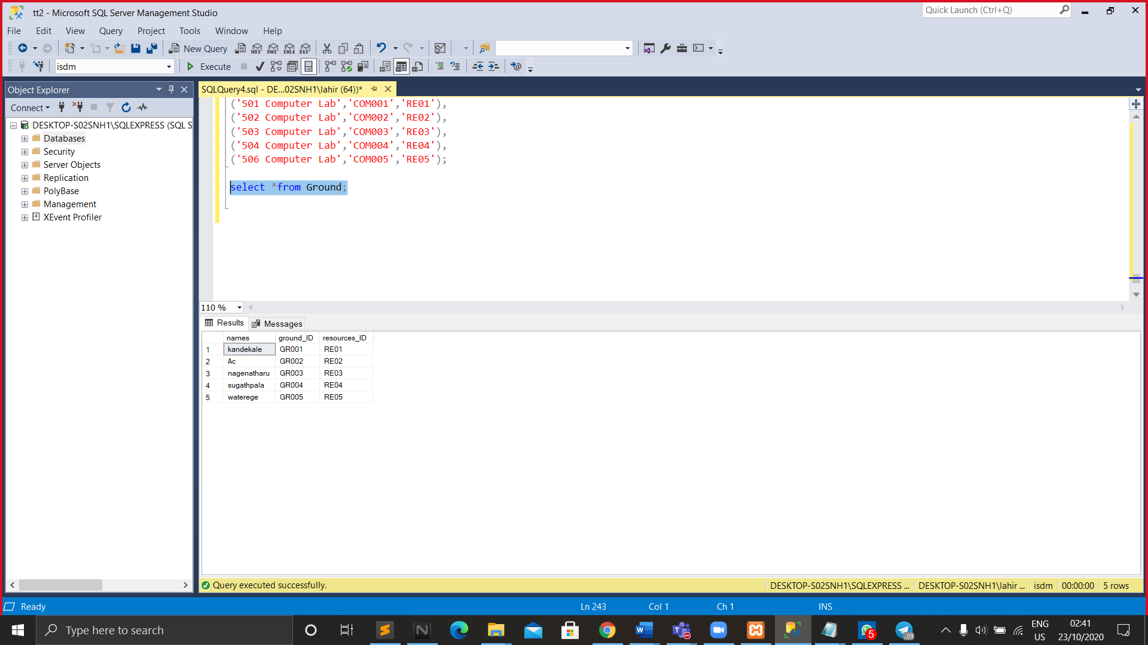**12.**

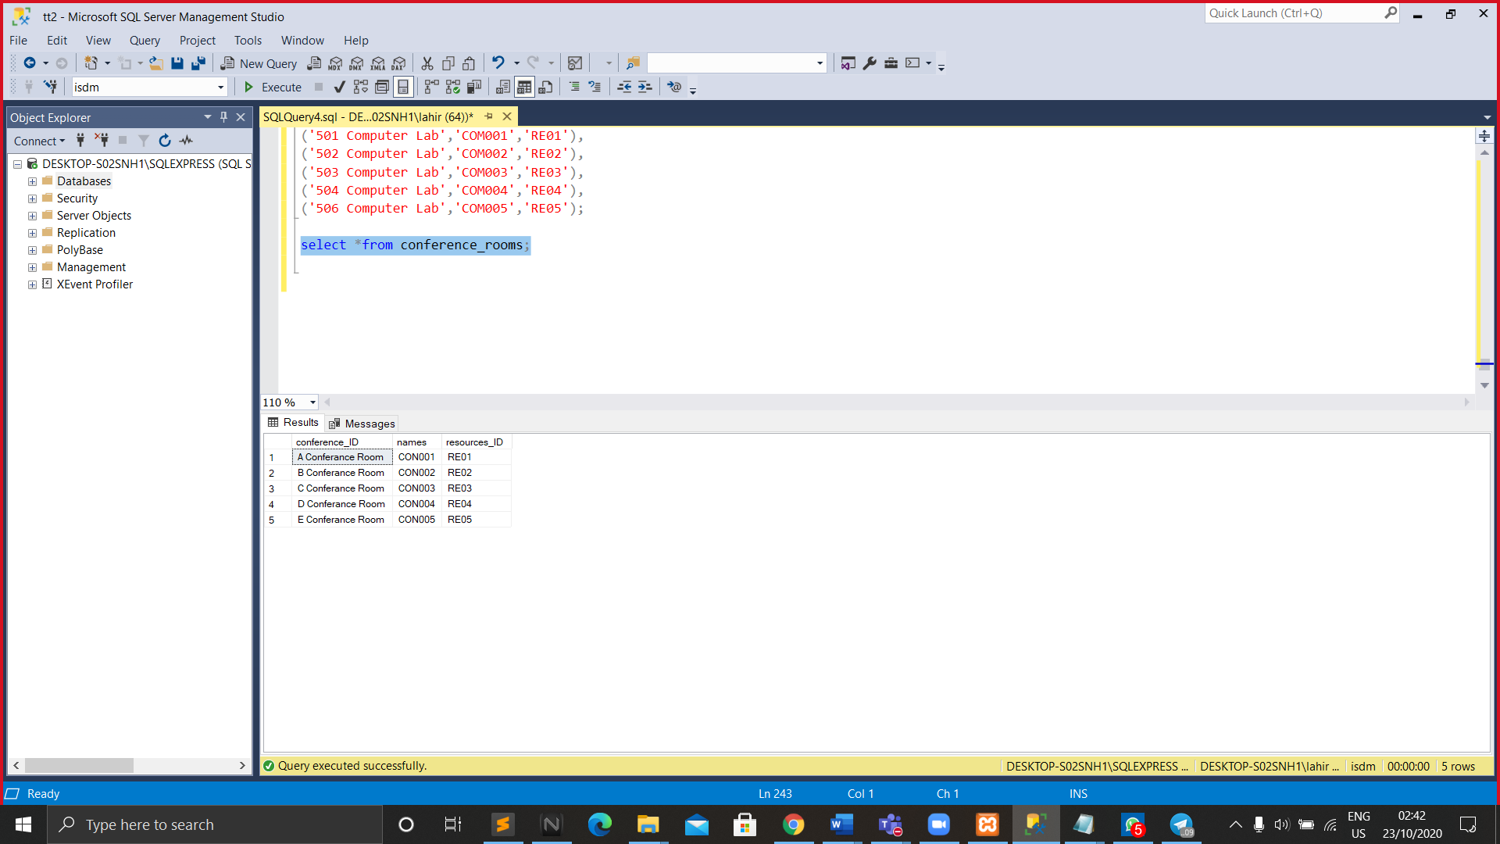**13.**

**14.**

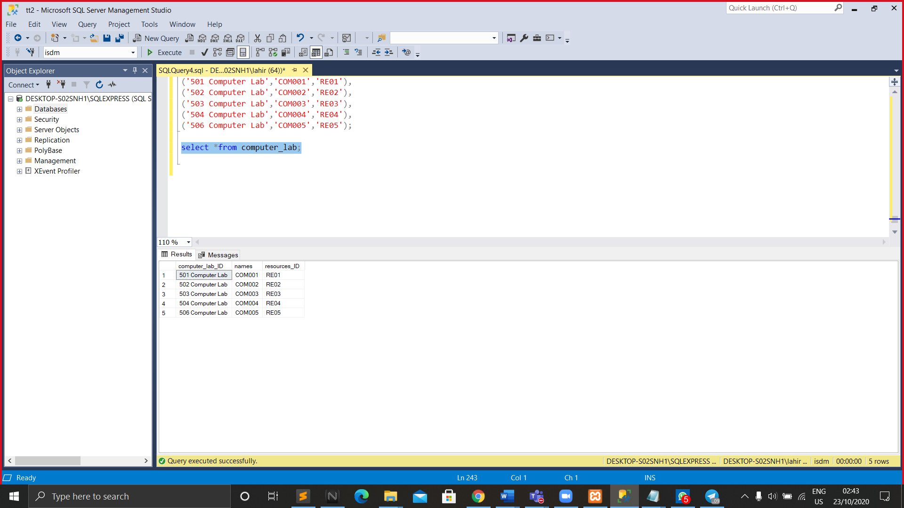

**Comments**

|  |  |  |  |  |
| --- | --- | --- | --- | --- |
| **Name and registration number** | **Individual contribution** | | **Lessons learnt** | |
| K.K.D.P.Kannangara  IT20014186 | * Requirement Analysis * SQL Tables   (Payment, Customer,  Appointment,  Packages,  Service_Providers)   * Designed and created the report * Analyzed the final output of assignment | | I learned to create requirement analysis documents, ER diagrams, final reports and SQL tables within a database. This was a great opportunity of proving teamwork, and happiness is we were able to complete this within very short period. I learned how to manage as the group leader. I am totally satisfied about the contribution and dedication of my team members. | |
| N.V.C.Pinto  IT20022624 | * Performance Requirements * Security   Requirements | | In this lesson I learnt how to build and how to use lesson points to design a computer database. | |
| H.M.Y.B.Gunarathne  IT20237486 | * Hypothetical scenario * Relational model schema * SQL Tables   (Items, Contact) | | Learnt to,  create tables and databases, add values to tables, design a schema, design an ER diagram. | |
| W.N.D.Wijerathne  IT20259884 | * Entity relationship diagram * SQL Tables   (Admin, News)   * Executed database with foreign, primary keys and sample   results | | I learned to make a requirement analysis document, separate data requirements, create ER diagrams and relational schema. I was able to solve the problems regarding to above sections. | |
| S.L.V.Wijerathne  IT20114244 | • | SQL Tables  (Orders,  Delivery_Driver,  Customer_Location,  Salons,Services,  Log_in | • | I could not understand some of the facts, but the members of my team explained it to me. This is very important and I learnt many things from it including create tables and design databases. |

Reference

* <https://www.visual-paradigm.com/guide/requirements-gathering/requirement-analysistechniques/>
* <https://www.tutorialspoint.com/software_engineering/software_requirements.html>
* <https://www.guru99.com/er-diagram-tutorial-dbms.html>
* <https://creately.com/blog/diagrams/er-diagrams-tutorial/>
* <https://byte-notes.com/relational-schema/>
* <https://www.w3schools.com/sql/sql_create_db.asp>
* <https://docs.microsoft.com/en-us/sql/relational->

THE END